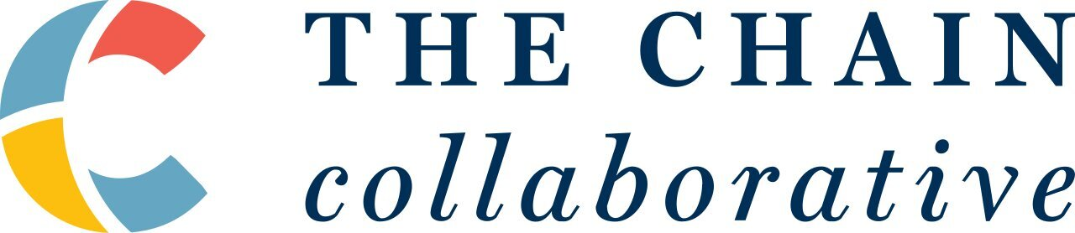 | a: 133 Federal Walk, Kennett Square, PA 19348  t: +1 (610) 348-6768  e: info@thechaincollaborative.org

TCC Program Fellowship Application

Name
Email
Address
Phone Number
Date of Birth
Social Media Handles (optional)

About

The Chain Collaborative enhances opportunities and capacities for community-led change in the coffee sector. We build relationships with local leaders in coffee-growing regions, cultivate their project design and management skills, and foster the development of their farming enterprises. Our work allows global communities to combat intergenerational poverty and marginalization in the coffee sector on their own terms, and according to their own visions for change. In addition to our work with grassroots leaders in coffee-producing communities, we also consult for mission-driven organizations and companies, train coffee professionals in sustainability through virtual coursework, and innovate across the value stream via special projects.

Our Belief in Sustainability Education

We believe that a deeper understanding of sustainability in the coffee sector can inspire a greater focus on social, environmental, and economic justice. Through our educational offerings, our goal is to promote a shared understanding of the complexities of sustainability in the value stream, through both practical and theoretical education. As part of this mission, we offer the three course levels of the Specialty Coffee Association (SCA)’s Coffee Sustainability Program to coffee and development professionals worldwide. In addition, we provide coursework independently and in collaboration with other institutions, such as Digital Coffee Future, The Center, and The Coffee Equity Lab at Vanderbilt. To deliver education, we also partner with other trainers and supply chain actors, such as Bean Voyage and A World in Your Cup.

TCC Program Fellowship

The TCC Program Fellowship provides the opportunity for Fellows to work alongside The Chain Collaborative on their community-led development and consulting projects. They will also learn how to engage in locally-led development in the coffee sector from an anti-top-down and anti-colonial perspective. In addition, Fellows have the opportunity to complete coursework with TCC, including all three levels—Foundation, Intermediate, and Professional—of the SCA Coffee Sustainability Program at no cost and/or additional TCC coursework as available throughout the year of their Fellowship. Over the course of the Fellowship, Fellows are expected to work alongside TCC for up to 8-10 hours a week. Coursework is considered separate from these hours.

Benefits to Fellow:

- Work experience alongside TCC, our Community-led Development Incubator participants, and other supply stream partners
- TCC mentorship throughout the program via meetings with TCC trainers, project staff, and project partners
- Recognition as a TCC Fellow via social media and other platforms
- Take coursework with TCC, including the Foundation, Intermediate, and Professional level modules of the SCA Coffee Sustainability Program at no cost (course fees and SCA exam fees are covered by the Fellowship); should Fellows have taken any of these courses prior to entering the Fellowship, they can supplement with additional TCC-led coursework

Program Requirements and Eligibility:

- Ability to work up to 8-10 hours a week in support of TCC programs in collaboration with our partners
- Interest in completing coursework with TCC
- At least 21 years of age
- Ability to offer a 10-month commitment from February 2024 through November 2024
- Interest in international development and coffee
- BA or equivalent preferred

Application Process:

- Send application by November 18, 2023 (complete all questions below and submit requested documents)
- Up to two rounds of remote video interviews with TCC staff in December 2023 and January 2024
- Final selection by January 20, 2024

Application Questions

Please answer all questions below, in this same document. Answers should be no more than 300 words in length.

- How did you hear about the TCC Program Fellowship? Be specific. What inspired you to apply for this Fellowship?

- What do you think are the merits and shortcomings of the current conversation and practices surrounding sustainability in the coffee industry today?

- How do you envision this Fellowship supporting your future career in or outside of coffee, if at all?

- What parts of the coffee sector have you worked in, if at all? Name one sustainability challenge you see in each of the parts of the sector that you have worked in.

- Do you have any international or remote working experiences? If so, what were they, and what were some of the most challenging aspects of the experiences? How did you overcome them?

- What are the skills you think you could bring to this Fellowship and to TCC’s partners?

- What type of volunteer work have you been involved in, or what networks have you been involved in, if any? Have you taken on leadership positions in those networks? (These volunteer opportunities or networks can be inside or outside of the coffee industry.)

- Name one person you admire for their work in sustainability, inside or outside of the coffee industry, and explain why.

References

Type | Professional
Name & Title
Contact information
Relationship to Fellow

Type | Academic
Name & Title
Contact information
Relationship to Fellow

Type | Volunteer
Name & Title
Contact information
Relationship to Fellow

Additional Required Documents

- Resume or CV
- One letter of recommendation from an above reference

Send this completed application along with the additional documents requested above to Tessa Tracy, Programs Manager for TCC at tessa@thechaincollaborative.org. Use the subject line “Your Name – TCC Program Fellowship Application.” Should you have any questions about the Fellowship, you may address them to the same email.

